Lord of Mysteries Guide

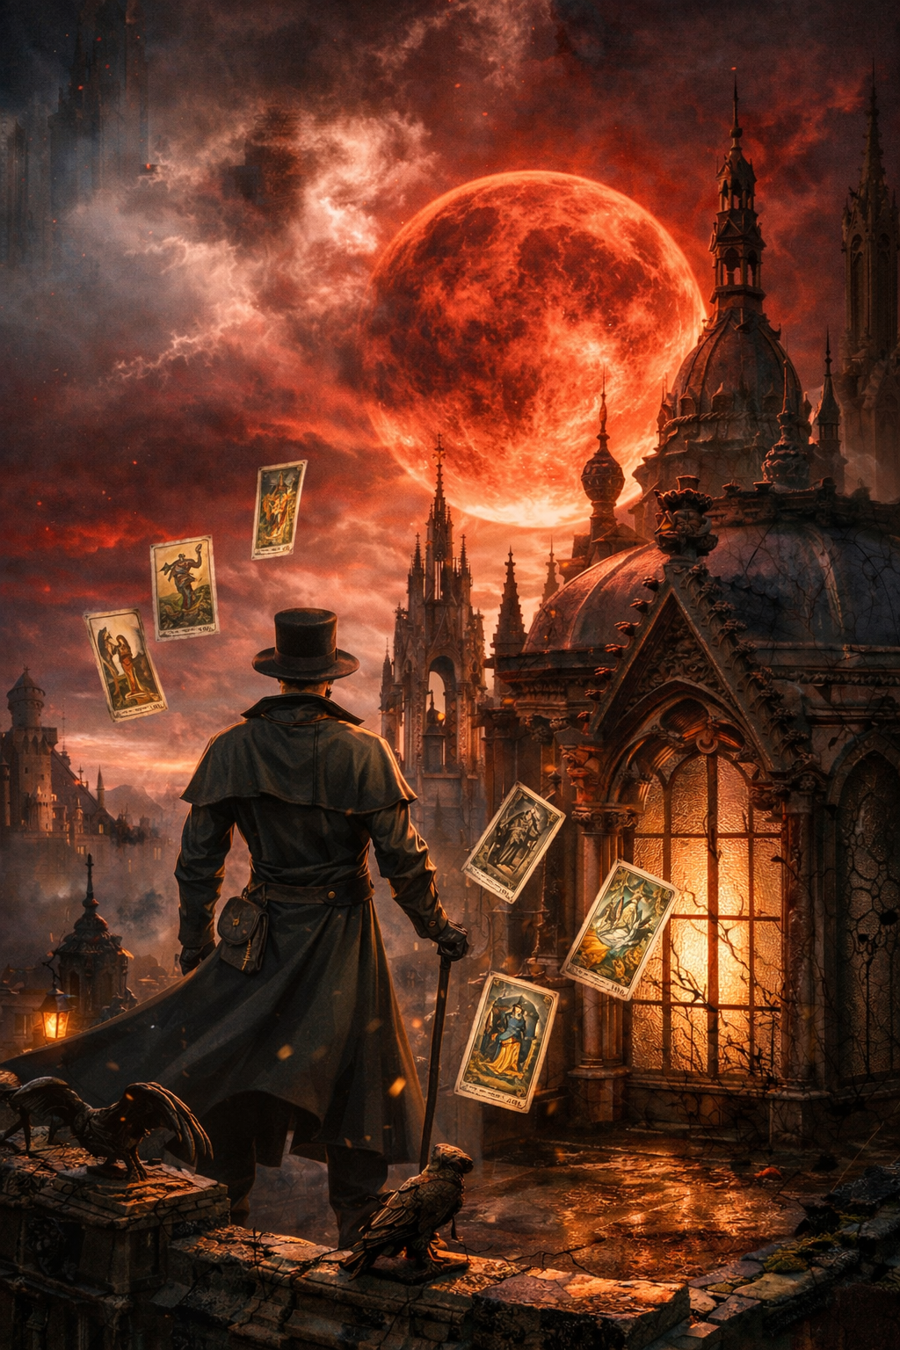

Contents

Lord of Mysteries Information Episode 1 moments -> Novel chapters 4

Chapter 1 Crimson, Chapter 2 Situation and Chapter 3 Melissa 4

Chapter 4 Divination 6

Chapter 5 Ritual 7

Chapter 6 Beyonder 10

Chapter 7 Code Names 12

Chapter 8 A New Era 16

Chapter 9 The Notebook 16

Chapter 10 The Norm and Chapter 11 Real Culinary Skills 16

Chapter 12 Here Again 16

Chapter 13 Nighthawk 16

Chapter 14 The Medium 16

Chapter 15 The Invitation 17

Lord of Mysteries Information Episode 2 moments -> Novel chapters 18

Chapter 16 Rat-Baiting with Dogs, Chapter 17 Special Operations Department, Chapter 18 Origin and Cause and Chapter 19 Sealed Artifacts 18

Chapter 20 The Forgetful Dunn, Chapter 21 An Old Friend in A Different World, Chapter 22 Starting Sequence, Chapter 23 Side Arm, Chapter 24 Penny-Pincher, Chapter 25 Cathedral, Chapter 26 Practice and Chapter 27 Siblings-Dinner 19

Chapter 28 Secret Order 19

Chapter 29 „Jobs” and Rentals Are Serious Business and Chapter 30 Brand New Beginning 19

From Chapter 16 – Chapter 30 is episode 2 00:00 – 14:00 Summarized 20

Chapter 31 Potion, Chapter 32 Spirit Vision and Chapter 33 Switch 20

Chapter 34 Advance Payment, Chapter 35 Exchange of Information and Chapter 36 A Simple Question 20

Chapter 37 The Club, Chapter 38 Novice Hobbyist and Chapter 39 Interesting Trick 21

Chapter 40 Mysticism Curriculum 21

Chapter 41 Audrey and Her Susie 21

Chapter 42 Butler Klee 21

Chapter 43 Search and Chapter 44 Fate 21

Lord of Mysteries Information Episode 3 moments -> Novel chapters 23

Chapter 45 Returning and Chapter 46 Portrait Episode 3 From 2:15 – 24

Chapter 47 Old Neil`s Lack of Money, Chapter 48 Hanass Vincent, Chapter 49 Divination Art, Chapter 50 Old Neil`s Method of Repayment, Chapter 51 The Grounded Ritualistic Magic, Chapter 52 Spectator, Chapter 53 Listener, Chapter 54 The First Divination Requester, Chapter 55 Revelation, Chapter 56 Escape From The Sea, Chapter 57 Organization and Summary, Chapter 58 A Train of Thought, Chapter 59 Roselle`s Origins, Chapter 60 Second Blasphemy Slate, Chapter 61 Strange Symbol, Chapter 62 The Seer`s Suggestion, Chapter 63 Dream Interpretation, Chapter 64 Instigator, Chapter 65 Beyonder Information, Chapter 66 Demoness Sect, Chapter 67 Response, Chapter 68 Monster, Chapter 69 Protection Amulet 24

Chapter 70 2-049`s Arrival, Chapter 71 Sluggish Phenomenon, Chapter 72 Tracking and Chapter 73 First Battle Episode 3 From 04:00 – 11:20 24

Chapter 74 Ray Bieber, Chapter 75 Saving Himself and Chapter 76 Dealing with The Aftermath Episode 3 From 11:20 – 25:20 24

Chapter 77 Remnant Items Episode 3 From 25:30 – 27:20 25

Chapter 78 Trauma and Chapter 79 Another Murmuring Episode 3 From 26:35 – 27:00 25

Chapter 80 Banquet Invitation 25

Chapter 81 Finally Meeting 25

Chapter 82 Herb Store 26

Chapter 83 Carving 26

Lord of Mysteries Information Episode 4 moments -> Novel chapters 27

Chapter 84 Elizabeth Episode 4 From 20:30 – 23:00 28

Chapter 85 Urgency, Chapter 86 Prayer and Chapter 87 Exhortation Episode 4 From 23:00 – 31:35 28

Chapter 88 Report Episode 4 From 31:35 – 33:35 28

Chapter 89 A Simple Mission, Chapter 90 Findings by Sight, Chapter 91 Solution and Chapter 92 Psychological Expert 28

Chapter 93 New Diary Page and Chapter 94 Hidden Sage 28

Chapter 95 The Supplicant 28

Chapter 96 Daly`s Guess 29

Chapter 97 Combat Teacher 29

Chapter 98 Mr. Azik 29

Chapter 99 Red Chimney 29

Chapter 100 Interpreting Symbols 29

Chapter 101 Unexpected Clue, Chapter 102 Cloth Merchant, Chapter 103 Doing as The Heart Willed, Chapter 104 Mr. Z and Chapter 105 Spirit Channeling 30

Chapter 106 Artist Klein 30

Chapter 107 Fors 30

Chapter 108 Deep into The Night, Chapter 109 Deduction and Chapter 110 Confirmation 30

Chapter 111 Letting Slip 30

Chapter 112 Azik`s Explanation, Chapter 113 Request and Chapter 114 The Standards of A Member 30

Chapter 115 Cheat and Chapter 116 Lanevus`s Child 31

Chapter 117 Contact 31

Lord of Mysteries Information Episode 5 moments -> Novel chapters 32

Chapter 118 August, Chapter 119 The True Lower Street, Chapter 120 Workhouse, Chapter 121 Leonard’s Hypothesis, Chapter 122 Target Building, Chapter 123 Beyonder Power, Chapter 124 Wrapping Up Work, Chapter 125 Bold Idea, Chapter 126 Divination Isn’t All – Powerful and Chapter 127 Laying the Foundations 32

Chapter 128 The Impoverished Fool, Chapter 129 Rampager and Chapter 130 Backlund`s Secret Gathering 33

Chapter 131 Transaction 33

Lord of Mysteries Information Episode 6 moments -> Novel chapters 34

Chapter 132 Meeting the Monster Again and Chapter 133 Expensive Charms Episode 6 From 02:02 – 02:20 35

Chapter 134 It`s Been More Than A Minute, Chapter 135 Portrait of A Baron and Chapter 136 The Stumped Klein Episode 6 From 02:20 – 07:00 35

Chapter 137 City of Silver and Chapter 138 Giant Pathway 35

Chapter 139 Studying 3-0782 and Chapter 140 Expert at Courting Death Episode 6 From 07:15 – 12:07 35

Chapter 141 Nightmare and Chapter 142 Association 35

Chapter 143 The Fool`s Real-Time Translator 36

Chapter 144 Three – Way Deal, Chapter 145 Request for Cooperation and Chapter 146 Creeping Hunger 36

Chapter 147 Night Visitor, Chapter 148 Messenger 36

Chapter 149 Direct Hint 36

Chapter 150 Azik`s Discovery and Chapter 151 Klein’s Request Episode 6 From 18:20 – 33:45 37

Chapter 152 Nice Attempt 37

Chapter 153 Final Act of Laying the Foundation 37

Chapter 154 Sharing „Experience” 37

Lord of Mysteries Information Episode 7 moments -> Novel chapters 38

Chapter 155 Urgent Meeting 38

Chapter 156 Melissa Who Takes the Long View 39

Chapter 157 Item of His Dreams, Chapter 158 Preparedness Averts Peril and Chapter 159 Bestowment and Sacrifice 39

Lord of Mysteries Information Episode 8 moments -> Novel chapters 40

Chapter 160 Seizing the Opportunity, Chapter 161 Inverted Mausoleum and Chapter 162 Intense Sunlight Episode 8 01:15 – 02:55 and 06:38 – 32:33 40

Lord of Mysteries Information Episode 9 moments -> Novel chapters 41

Chapter 163 Various Signs, Chapter 164 Miserable Wretches and Chapter 165 Epitaph Episode 9 From 15:00 – 32:10 41

Chapter 166 Examination, Chapter 167 Holy Artifact, Chapter 168 Clown Potion and Chapter 169 New Abilities Episode 9 From 06:50 – 15:00 41

Lord of Mysteries Information Episode 10 moments -> Novel chapters 42

Chapter 170 Copper Whistle Episode 10 From 01:20 – 04:45 42

Chapter 171 Promotion and Pay Raise and Chapter 172 „Autopsy” Episode 10 From 21:00 – 23:44 43

Chapter 173 Zombification and Chapter 174 Madam Sharon 43

Chapter 175 Deduction 43

Chapter 176 Letter, Chapter 177 Sudden Turn of Events, Chapter 178 The Subsequent Ideas, Chapter 179 Praising Mr. Fool and Chapter 180 A Smart Person Always Overthinks 43

Chapter 181 Different State and Chapter 182 Wanderer Klein 43

Chapter 183 A Lesson on Mediumship 44

Chapter 184 Behind the Gate, Chapter 185 Spiritual World and Chapter 186 The Handsome Captain Episode 10 From 11:45 – 21:00 44

Chapter 187 Azik`s Warning, Chapter 188 Ball, Chapter 189 Prayers and Replies, Chapter 190 The Assortment of Abilities, Chapter 191 Unclear Motives, Chapter 192 Attention and Chapter 193 Coming to A Close 44

Lord of Mysteries Information Episode 11 moments -> Novel chapters 45

Chapter 194 Infiltration and Chapter 195 „Lockpicking Expert Klein” Episode 11 From 09:50 – 11:15 45

Chapter 196 Spirit Medium Mirror, Chapter 197 Operation, Chapter 198 Appropriating Uniqueness, Chapter 199 Successful Toss of The Die and Chapter 200 The Demoness of Pleasure Episode 11 From 14:40 – 27:15 46

Lord of Mysteries Information Episode 12 moments -> Novel chapters 47

Chapter 201 Inquiry Episode 12 From 01:17 – 04:37 47

Chapter 202 Confirming the Situation Episode 12 From 05:55 – 06:06 47

Chapter 203 Mutant, Chapter 204 Visitor, Chapter 205 Urgent Arrangement, Chapter 206 Grade 2 Sealed Artifacts and Chapter 207 Guardian Episode 12 From 07:10 – 26:30 47

Lord of Mysteries Information Episode 13 moments -> Novel chapters 48

Chapter 208 Cry and Chapter 209 Light Episode 13 From 01:14 – 19:10 48

Chapter 210 Story Episode 13 From 19:10 – 22:12 48

Chapter 211 Funeral Episode 13 From 22:12 – 27:30 48

Chapter 212 Avenger and Chapter 213 Another Look Episode 13 From 27:30 – 30:33 48

# Lord of Mysteries Information Episode 1 moments -> Novel chapters

**How to use this episode guide**

This guide is meant to be read *after watching the episode*. You do **not** need to read all listed chapters.

Only read the chapters that are explicitly marked as:

**“skipped”, “missing”, or “key information omitted”**.

Chapters mentioned only for comparison or timeline reference do not need to be read.

## Chapter 1 Crimson, Chapter 2 Situation and Chapter 3 Melissa

The anime shows almost the same way the book describes the action , “almost” because the anime is making everything more engaging by having him being followed by someone and everything is happening so fast you can’t keep up with information , probably why they left out a lot of information that Zhou Mingrui gathers from this 3 chapters , everything later feels like he already knows enough even though he didn’t learn anything in the anime

Key differences:

* Klein is not followed by anyone like the anime shows when he leaves the house
* Before leaving his house to go buy bread he is taking his revolver with him, but he leaves one chamber empty in case he misfires
* Leonard is not protecting him all this time either
* When the clown gives him the flyer, he is approached by the animal trainer for a tarot reading

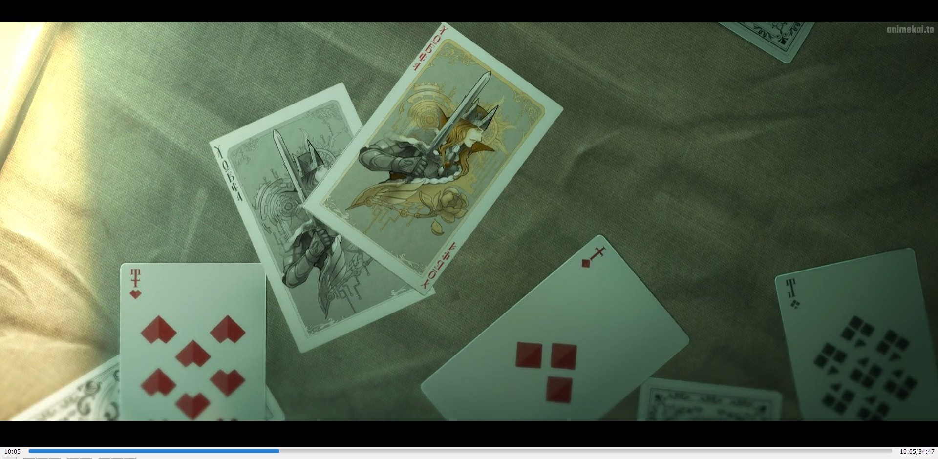

## Chapter 4 Divination

General Knowledge about Roselle Gustav “Senior Transmigrator”

This pronunciation was almost identical to the tarot cards on Earth!

And tarot cards from Earth were a set of cards used for divination. They just had graphics that represented different omens.

*Wait…* He suddenly recalled the origins of tarot divination in this world.

It did not originate from the seven orthodox gods nor was it an ancient legacy. Instead, it was created by the Intis Republic’s Consul of that era, Roselle Gustav, more than 170 years ago.

This Mr. Roselle invented the steam engine, improved the sailing boat, overthrew the Intis Kingdom’s imperial rule, and was recognized by the God of Craftsmanship. He also became the first Consul of the Intis Republic.

Later, he invaded other nations and placed Lenburg and other nations under his protection. He made the Loen Kingdom, Feynapotter, Feysac Empire and other powerful Northern Continent nations bow down to the Intis Republic. Following that, the Republic was then changed to an Empire and he became the self-proclaimed ‘Emperor Caesar.’

It was during Roselle’s rule that the Church of Craftsmanship received its first public holy revelation since the Fifth Epoch. Ever since, the God of Craftsmanship was changed to the God of Steam and Machinery.

Roselle also invented tarot divination. He also established the contemporary system of paper-based cards and their playstyles. There were many familiar styles that Zhou Mingrui was familiar with, such as Upgrade, Fighting the Landlord, Texas Poker, and Quint…

In addition, the marine fleets he sent out discovered a sea route that led to the Southern Continent through the stormy and turbulent seas. This also began the era of colonialism.

Unfortunately, he was betrayed in his old age. In the year 1198 of the Fifth Epoch, he was assassinated by the combined forces of the Church of the Eternal Blazing Sun, the former Intis royal family—the Sauron family—and other aristocrats. He eventually died in the White Maple Palace.

*This…* To recall such general knowledge suddenly made him facepalm.

*Could this be a transmigration senior?*

## Chapter 5 Ritual

He just sighed and did not think further about it as he hurried back home. With the staple food, he could now carry out the luck enhancement ritual!

†

After the second-floor tenants gradually left, Zhou Mingrui was still in no hurry to carry out the ritual. Instead, he translated the “The Immortal Lord of Heaven and Earth for Blessings” and related phrases into the ancient Feysac language, as well as the Loen language. He was intending to try the ritual again the next day in those local languages if the original incantation did not take effect!

After all, he had to take into consideration the differences between the two worlds. In Rome, do as the Romans do!

As for translating it into an ancient ritual prayer that used the dedicated Hermes language, Zhou Mingrui had a difficult time completing it due to his lack of vocabulary.

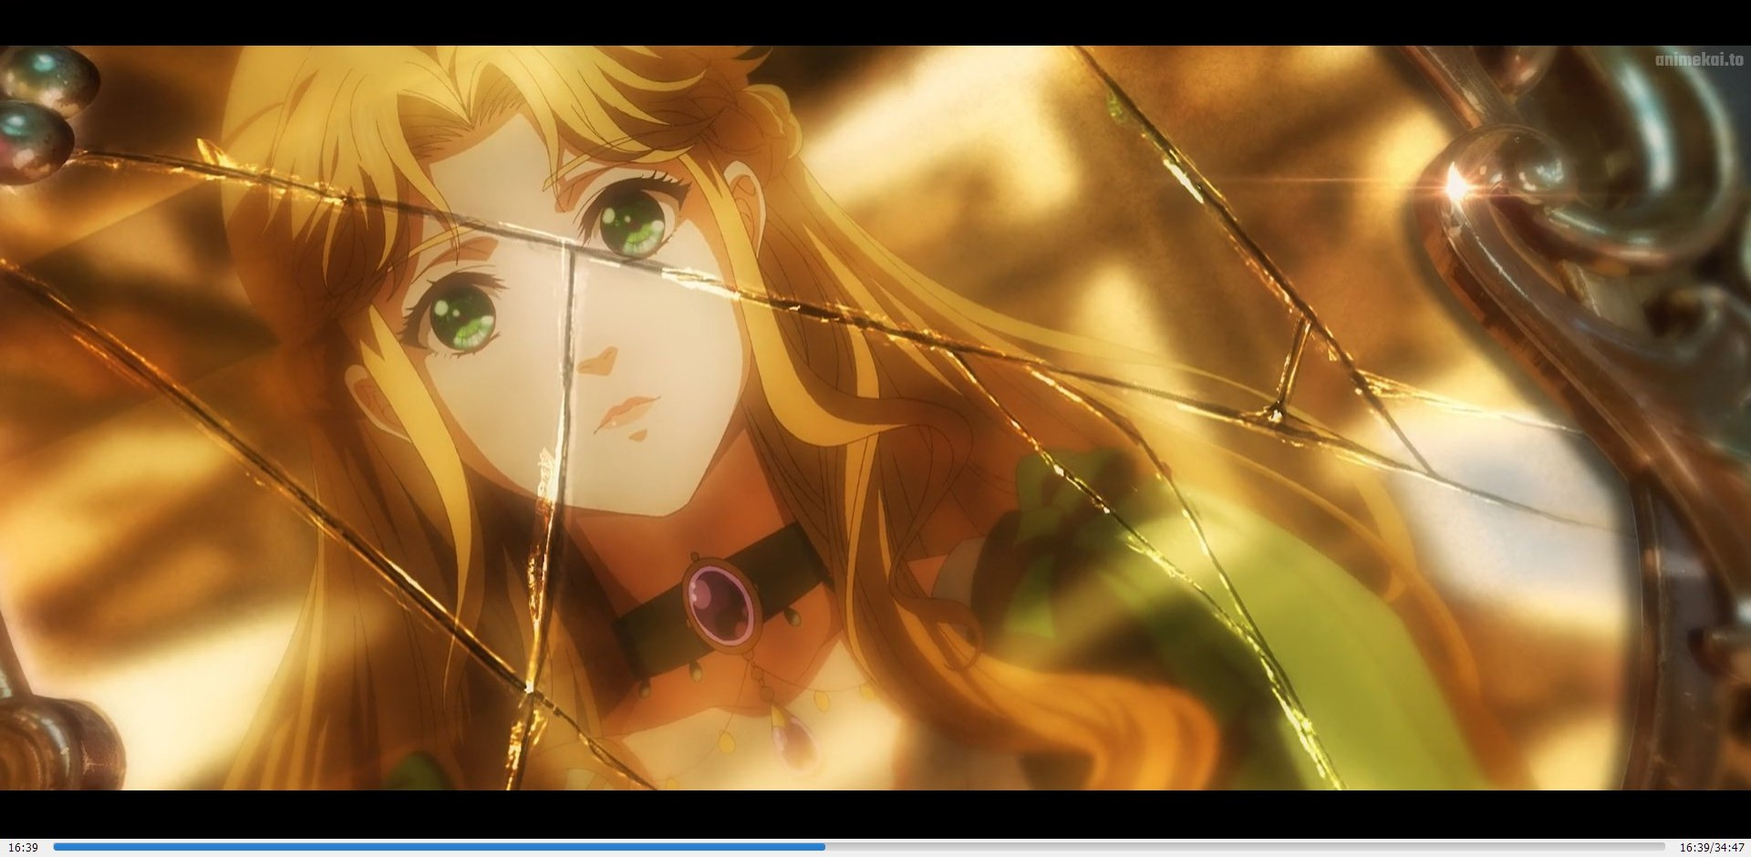

†

In the Loen Kingdom’s capital, Backlund. Inside a luxurious looking villa at the royal district.

Audrey Hall sat in front of a dresser. The markings on it were antiquated and there was a cracked bronze mirror on the surface.

“Mirror, mirror, awaken…

“In the name of the Hall family, I command you to awaken!”

†

She switched between many different sayings, but there was no reaction from the mirror at all.

After more than 10 minutes, she finally chose to give up and pouted her lips in grievance. She said in a soft murmur, “Father was indeed lying to me. He always tells me that this mirror was the treasure of the Solomon Empire’s Black Emperor, and that it is an extraordinary item…”

Her voice trailed off. The bronze mirror which rested on the dresser suddenly glowed with a crimson light that shrouded her completely.

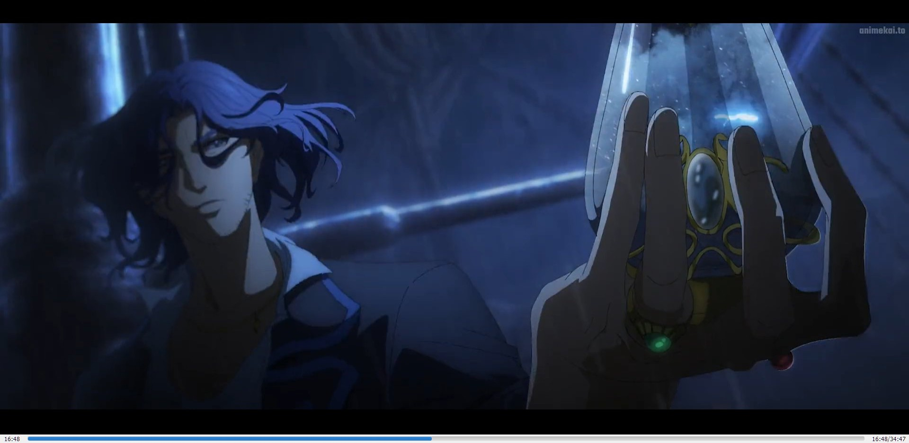

†

In the Sonia Sea, a three-masted sailboat that looked like an obvious relic was navigating through a storm.

Alger Wilson stood on deck, his body undulating with the currents at sea, maintaining his balance easily.

He wore a robe embroidered with lightning patterns, and in his hand was a quirky- shaped glass bottle. Bubbles billowed inside the bottle at times, frost turned into snow at times, and signs of gusting wind could be seen at times.

“Still short on the Ghost Shark’s blood…” Alger murmured.

Then at this moment, a crimson burst appeared in the space between the glass bottle and the surface of his palm. In an instant, it enveloped the surroundings as well.

## Chapter 6 Beyonder

Not only did they speak the same Loen language, they also shared the same grim and tense vibes.

*Where am I? What do I plan to do here? I would like to know too…* Calming himself down, Zhou Mingrui silently repeated the questions posed by the two.

What left the deepest impression on him were neither the sentences formed by words nor the meanings behind them, but the display of bewilderment, vigilance, panic, and reverence by the couple!

For some baffling reason, two people had been mysteriously dragged into this world surrounded by gray fog. As the perpetrator, Zhou Mingrui was already feeling abnormally dumbfounded and startled, let alone the couple who was pulled into this mess completely passively!

For them, such events and encounters might already be beyond their imaginations, right?

Momentarily, Zhou Mingrui thought of two options: The first option was feigning victimhood to hide his true identity, and in turn gain a considerable amount of trust. He could then take a wait-and-see approach and take advantage of his circumstances where necessary. The other option was to maintain his mysterious identity in the eyes of the couple. He could then affect the subsequent development while gleaning valuable information from them.

Without the luxury of time to deliberate over the situation, he grasped hold of the thought that flashed across his mind. He made an immediate decision to try out the second idea.

Exploit the psychological state of the others to gain the greatest advantage for himself!

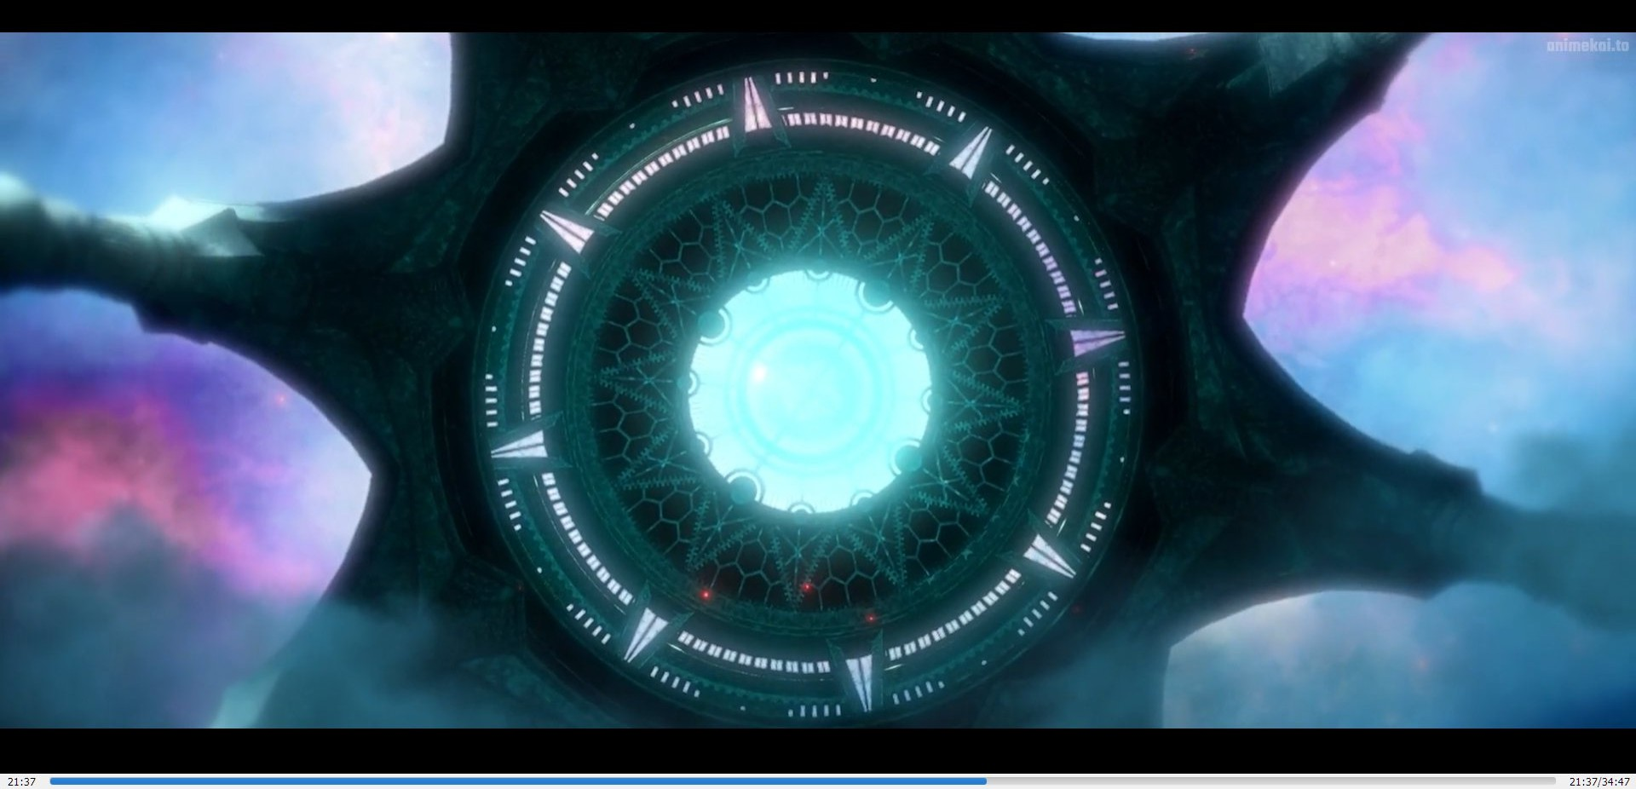

Alger leaned back slightly, and replied unhurriedly, “As you know, humanity can only depend on potions to become real Beyonders, while the names of potions come from the ‘Blasphemy Slate.’ After constant translations into Jotun, Elvish, ancient and modern Hermes, and ancient Feysac, they have undergone changes to match the day and age of that era. The essence is not in their names, but whether they portray the ‘core characteristics’ of the potions.

“I have a Sequence 9 Potion named ‘Sailor.’ It enables you to have excellent balancing capabilities. Even if you were on a boat in a rainstorm, you will be able to walk about freely as though you were on land. You will also gain immense strength and illusory scales under your skin. They will enable you to swim like a fish and be difficult to catch. You will move agilely underwater just like marine animals. Even without any equipment, you will be able to easily submerge underwater for at least ten minutes.”

“Sounds great… the ‘Keepers of the Seas’ from the Lord of Storms?”

“It was called by that name in the past.” Alger did not pause and continued. “The second Sequence 9 potion is called ‘Spectator.’ Although I am not sure what it was called in the past. This set of potions enables you to have an exceptionally sharp mind with acute observational abilities. I believe you can understand what ‘spectator’ means from watching operas and plays. Just like an audience, spectators judge the ‘actors’ in the secular world, catching a glimpse of the real thoughts of them through their emotions, conduct, and mantras.”

At this point, Alger emphasized, “You must remember, regardless of whether you are at an extravagant banquet or a crowded street, spectators can only be spectators forever.”

Audrey’s eyes shone as she listened, and spoke after a long while, “Why? Alright, this is a follow-up question. I-I think I have fallen in love with this feeling—of being a ‘Spectator.’ How can I get this potion’s formula? What can I use to trade with you for it?”

Alger looked like he was already prepared as he said in a deep voice, “The blood of Ghost Sharks, at least 100 milliliters of it.”

Audrey nodded her head excitedly, but subsequently asked worriedly, “If I can get it—and I’m saying if—how do I hand it to you? How can you promise me that you can give the potion’s formula to me in return for the Ghost Shark’s blood, as well as the authenticity of the formula?”

Alger said calmly, “I’ll give you an address. I’ll mail the formula to you, or tell you directly here, once I receive the blood of the Ghost Shark.”

“As for promises, I think that both you and I can feel assured under the witness of the mysterious sir.”

## Chapter 7 Code Names

“Continue, the both of you.”

Alger nodded and sat back down before looking at Audrey.

“If you can obtain the Ghost Shark’s blood, get someone to send it to the Warrior & Sea Bar at Pelican Street, in the White Rose Borough of Pritz Harbor. Tell the boss, Williams, that it’s what the ‘Captain’ wants.

“Once I acknowledge receipt, will you be giving me an address to mail the potion formula to or do you want me to tell it to you here directly?”

Audrey thought for a moment before saying with a smile, “I will choose the more secure method. Let’s do it here, although it’s a test of my memory.”

Since Mr. Fool had agreed to bear witness for the trade, it also represented that there would be a similar ‘gathering’ the next time.

With this in mind, she suddenly turned her head as she looked at Zhou Mingrui with sparkling eyes. With a tone of interest, she suggested, “Mr. Fool, would you mind making a few more ‘attempts’ like this?”

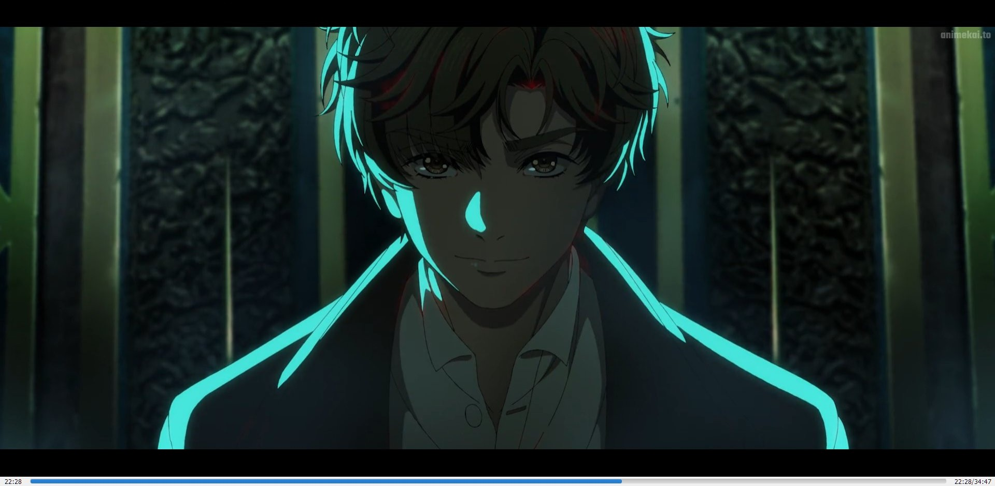

However, more gatherings meant it was easier to expose himself!

*Indeed, regardless of the world, there is no such thing as a free lunch…* Zhou Mingrui extended his right hand again as he rapped the side of the long table with his finger gently.

Considering the fact that he was in control of the gathering’s summoning and dismissal, any threat of exposure was within the confines of his control. The pros clearly exceeded the cons, so Zhou Mingrui rapidly made a decision.

He stopped his rapping as he smiled at the anticipative and perturbed gazes of the duo.

“I’m a person who likes a fair and equal exchange. “Your help will not go unrewarded.

“Every Monday at three in the afternoon, try your best to be alone. After I make a few more attempts and figure out certain things, perhaps you can apply for a leave of absence ahead of time. You will no longer need to worry about being in inappropriate situations.”

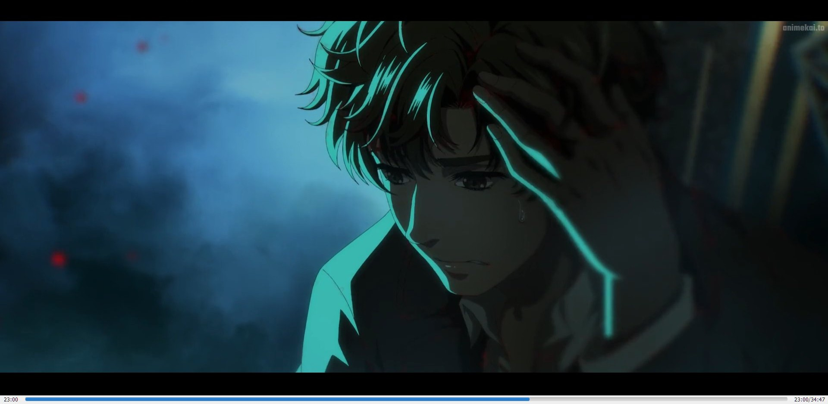

Following that, she looked at Alger.

“Mr. Hanged Man, can you repeat the address again once more? I’m afraid that my memories will fail me.”

“No problem.” Alger was very pleased with Audrey’s seriousness as he repeated the address once more.

After repeating it to herself silently thrice, Audrey said again in excitement, “I heard that tarot cards were invented by Emperor Roselle as a game. In fact, doesn’t it come equipped with the power to divine the future?”

“No. Most of the time, divination stems from one’s self. Everyone has something spiritual about themselves, allowing them to attune to the spiritual world and connect to information about themselves at an even higher level. However, ordinary folks are unable to notice this, much less be able to interpret the ‘signs’ they receive. This information will present itself with the help of divination tools. Let me raise a simple example, dreams and dream interpreters.” Alger took a glance at Zhou Mingrui and seeing no response from him, he refuted Audrey’s claim. “Tarot cards are, in fact, such a tool. It uses more symbolism and more logical elements to help us in conveniently and accurately interpreting the signs.”

Although Zhou Mingrui appeared indifferent, he was actually listening very carefully. It was only at this point that his empty mind slowly became heavy as his head began to feel a throbbing pain.

“Got it.” Audrey nodded in agreement. Following that, she emphasized, “That’s not what I meant. I’m not doubting the tarot cards, but I heard that Emperor Roselle had actually created another set of cards, secret and mysterious ones. They were paper cards which symbolized a particular unknown power. There were a total of twenty- two cards that he completed. Later on in life, he referenced them to create the twenty-two Major Arcana tarot cards which are used as a gaming tool. Was what I said correct?”

She looked at Zhou Mingrui as though she was attempting to get an answer from the mysterious Mr. Fool.

All Zhou Mingrui did was smile without saying a word. He cast his gaze at The Hanged Man as though he was putting him to the test.

Alger subconsciously straightened his back and said in a deep voice, “That’s right. It is said that Emperor Roselle had seen the Blasphemy Slate and that set of paper cards contain the profound mysteries of the twenty-two paths of the divine.”

“Twenty-two paths of the divine…” repeated Audrey with a longing tone.

At that moment, Zhou Mingrui’s headache intensified. He felt that his invisible connection with the crimson stars and grayish-white fog was beginning to falter.

“It was like a dream… What the heck was that foggy world… Who or what sort of power created the changes that just happened…” Zhou Mingrui sighed softly. He was completely puzzled as he walked towards the study desk as though his legs were filled with lead.

He picked up the pocket watch he placed outside to determine how much time had passed.

“Time flowed at the same pace.” Zhou Mingrui made a rough judgment.

After putting down his pocket watch, he found himself unable to endure the splitting headache any further. He sat on the chair and lowered his head, using his left thumb and middle finger to massage his temples.

After a long while, he suddenly let out a sigh and said in Mandarin, “From the looks of it, I won’t be able to return any time soon…”

Only the clueless could be fearless. After witnessing such a fascinating event and learning the situation regarding Beyonders and the mysterious world, Zhou Mingrui no longer dared to rashly try the luck enhancement ritual using ancient Feysac or Loen language.

Who knew what other kinds of situations would happen. Perhaps, it would be more bizarre, horrifying, or even a living hell!

“At the very least, I should attempt only when I have a deep mastery of mysticism,” thought Zhou Mingrui helplessly.

Thankfully, the so-called gathering could provide him with help.

After another bout of silence, he muttered to himself with a tone of dismay, disappointment, agony, and grief, “From this moment forth, I’m Klein.”

†

Klein tried his best to refocus his solutions and plans so as to purge the negative emotions in him.

Perhaps, he could learn the potion formula for ‘Spectator’ from the side…

*The ‘gathering’ that just happened sure is fascinating. People who reside in different places across the world can reduce hundreds of kilometers to just mere inches and discuss face-to-face while supplying each other’s needs. Uh, speaking of which, this does sound a little familiar…*

Klein was stunned for a few seconds before he burst out in laughter. Pressing against his temple, he jested under his breath, “Wasn’t that a social networking platform?”

## Chapter 8 A New Era

Hole chapter is missing from the episode at 23:40

This chapter is about The Hanged Man and Justice, time after they get sent back

## Chapter 9 The Notebook

Hole chapter is missing from the episode at 23:42

This chapter is about Klein learning from his diary and recovering his strength by sleeping 3 hours and also cooking a meal for himself

Only at the end of the chapter is someone knocking at the door

## Chapter 10 The Norm and Chapter 11 Real Culinary Skills

In these chapters is what really happened not like in the anime

## Chapter 12 Here Again

Is what happened in the anime until 30:00

## Chapter 13 Nighthawk

This chapter is missing

Klein learns about beyonders and about his friend’s deaths also he is led by Dunn Smith to Welch’s residence to see the spirit medium, she is not with him like in the anime

## Chapter 14 The Medium

Daly Simone questions him about the Antigonus Notebook and his missing memory, but she does not learn anything important this is what happens in anime at 30:00 – 32:30

Klein also is told about the dangers of becoming a beyonder and is invited to join the Nighthawks (not necessarily as a beyonder, but as a civilian member)

## Chapter 15 The Invitation

In this chapter Dunn Smith presents the advantages and disadvantages of becoming one of the Nighthawks and also gives Klein an address to go to if he decides to become one

This hole chapter is missing with only the address and a card appearing in episode 2 of the anime

# Lord of Mysteries Information Episode 2 moments -> Novel chapters

* **READ – Chapters that contain missing or crucial information not explained in the anime**

**🔁 REFERENCE – Chapters mentioned only for timeline or adaptation comparison**

⏳ **NOT ADAPTED YET – Chapters that will appear in later episodes, OVA, or movie If you want clarification after Episode 2, bare minimum to read:**

* + Chapter 28 (Secret Order)
  + Chapters 31–33 (Potion & Spirit Vision)
  + Chapters 37–40 (Acting Method & Divination)
  + Chapter 44 (Dream Revelation context)
* READ – Skipped foundation (Nighthawks & world rules)

## Chapter 16 Rat-Baiting with Dogs, Chapter 17 Special Operations Department, Chapter 18 Origin and Cause and Chapter 19 Sealed Artifacts

In those chapters Klein goes to the address he has and learns about the security company from another street, there is the HQ of the Nighthawks, then when he goes in, he is guided by Rozanne and is also „hired” as a civilian member of the Nighthawks

Key differences from anime:

* + He is not going to become a beyonder yet he only learns about beyonders dark side and the

„losing control” part from the captain

* + He is also learning about the pathways, the churches, the other civilian members of the Nighthawks and Sealed Artifacts (because he is told about Chanis Gate)
  + He is also sent to practice shooting and is given demon hunting bullets and an advance

payment

* + Klein`s only job was to try to remember what happened on the 27th and is told only to retrace he`s steps

**Why this matters:**

These chapters establish why Klein is cautious about becoming a Beyonder.

In the anime, this hesitation is skipped, making his later decision to advance feel rushed and less grounded.

* READ – Character grounding & motivation

## Chapter 20 The Forgetful Dunn, Chapter 21 An Old Friend in A Different World, Chapter 22 Starting Sequence, Chapter 23 Side Arm, Chapter 24 Penny-Pincher, Chapter 25 Cathedral, Chapter 26 Practice and Chapter 27 Siblings-Dinner

All these chapters have been skipped in the anime

**Why these chapters matter:**

These chapters develop Klein’s daily life, financial pressure, family responsibility, and slow adjustment to the mysterious world — grounding his later choices emotionally.

* READ – Critical decision context

## Chapter 28 Secret Order

In this chapter, after Klein is being pursued in the latest chapters and saves himself by going to the Cathedral and through it entering the Nighthawks HQ, in the middle of the night he is suddenly awaken by the captain and is told that there is an intruder

After they resolve the incident Dunn tells him about the other Sequences and the potions they hold and what they mean (in the previous chapters Klein reads some of Roselle diary pages and learns that the emperor regretted not choosing one of the 3: Apprentice, Marauder, or Seer!)

Key difference from the anime is that all of this was summarized to Klein going to Old Neil learning about Sleepless, Corpse-Collector, Mystery Pryer and Seer, then after seeing the emperor’s diary pages he chooses Seer (not really what happened in the web novel)

**Important clarification for anime viewers:**

Klein’s choice of the Seer pathway is not a single moment decision.

It is the result of fear, limited options, Roselle’s warnings, and practical survival concerns — most of which are skipped or compressed in the anime.

🔁 REFERENCE – Decision aftermath (compressed in anime)

## Chapter 29 „Jobs” and Rentals Are Serious Business and Chapter 30 Brand New Beginning

In those chapters Klein learns about the Seer potion abilities and after everything settles down, he is thinking that he should become a beyonder as well after reading Roselle diary and seeing that he needs some abilities to protect himself also he needs to learn about mysticism, so he is keen on selecting Seer (his other choice was Mystery Pryer)

After he settles on a potion and becoming a beyonder, he learns his „job change” is going to get him a raise and discusses with his siblings to move to a better home

Key difference from the anime is that all this didn`t happen and he went straight to becoming a beyonder from the Seer Pathway

**Why this matters:**

In the anime, Klein appears decisive and confident.

In the novel, this decision is reluctant and defensive — changing how we understand his character.

🔁 REFERENCE – Timeline compression note

## From Chapter 16 – Chapter 30 is episode 2 00:00 – 14:00 Summarized

* READ – Power mechanics (missing explanation)

## Chapter 31 Potion, Chapter 32 Spirit Vision and Chapter 33 Switch

In those chapters Klein learns about the potions, how to concoct them and about ingredients, he also learns about his power „Spirit Vision” and how to turn it on and off

Key information from these chapters was left out in the anime

This omission is one of the main reasons anime-only viewers struggle to understand how powers work in later episodes.

From 14:00 – 20:07 in the anime everything that has happened in the latest chapters is shown in several moments, but without any details and everything is moving so fast without any information on how they got to those points

⏳ NOT ADAPTED YET – Future Tarot Club developments

## Chapter 34 Advance Payment, Chapter 35 Exchange of Information and Chapter 36 A Simple Question

In those chapters another „gathering” was held and the transaction between The Hanged Man and Justice was done and he managed to get to Sequence 7 Seafarer and she got the potion to Sequence 9 Spectator

Key difference is that in the anime this is not happening yet

**Timeline note:**

This gathering has not happened yet in the anime, even though later episodes reference its consequences.

* READ – Acting Method (core digestion mechanic)

## Chapter 37 The Club, Chapter 38 Novice Hobbyist and Chapter 39 Interesting Trick

In these chapters Klein while doing his „Job” sees a Divination Club and decides to enter and try the

„acting method”, after realizing he doesn`t have enough money to enroll he decides to have let someone there do a divination for him so he may find the Antigonus Notebook

Klein then goes to the security company where he is confronted by Leonard about his „suicide”, after they talk, he goes to practice his shooting; after finishing he meets Old Neil for some mysticism lessons

**Crucial missing concept:**

The acting method explains why Klein’s potion digests.

Without it, the anime shows results without explaining the cause.

## Chapter 40 Mysticism Curriculum

In this chapter Klein learns about divination

Key information from all these chapters is missing in the anime

🔁 REFERENCE – Rearranged mission setup

## Chapter 41 Audrey and Her Susie

In this chapter Audrey becomes a Spectator, and the Nighthawks receive a mission request

## Chapter 42 Butler Klee

In this chapter Leonard accepts the request and involves Klein in it because he needs a Seer to help him finish it faster

Key information: in anime from 21:10 – 22:00 is what happened in this chapter but way too fast and different from the web novel

* READ – Dream revelation context

## Chapter 43 Search and Chapter 44 Fate

In those chapters Klein and Leonard manage to save the kid and turn back to the security company

Key information: at the end of chapter 44 Klein has a dream revelation about the Antigonus Notebook (because the house where the kidnappers where hiding was close to the notebook)

In the anime from 29:00 – 31:43 is where he gets the dream revelation and is exactly at the door, he is looking which is not accurate with the web novel

What happens from 33:40 – 36:15 happened in the book way earlier and has no connection to the story so far, it is just a way to show some moments with the siblings in the anime

**Why this change matters:**

In the novel, the revelation feels coincidental and unsettling.

In the anime, placing Klein directly at the door removes that sense of creeping fate.

# Lord of Mysteries Information Episode 3 moments -> Novel chapters

* **READ – Chapters that contain missing or crucial information not explained in the anime**

**🔁 REFERENCE – Chapters mentioned only for timeline or adaptation comparison**

⏳ **NOT ADAPTED YET – Chapters that will appear in later episodes, OVA, or movie Important note about Episode 3**

**Episode 3 heavily rearranges the novel’s chronology.**

**Many chapters listed below are not meant to be read all at once.**

**They are grouped to show what information the anime assumes you already know, what is skipped, and what is moved to later episodes.**

**If you want clarification after Episode 3, bare minimum to read:**

* + **Chapter 77 – Remnant Items**
  + **Chapters 78–79 – Trauma / Another Murmuring**
  + **Chapters 37–40 – Acting Method & Divination *(Optional, if not already read in Episode 2)***

• Chapter **77 – Remnant Items**

*Why:*

* Explicitly names **Sequence 8: Clown**
* Confirms Klein’s intention to advance as a formal Beyonder
* The anime assumes this knowledge but never states it clearly

• Chapters **78–79 – Trauma / Another Murmuring**

*Why:*

* Explain interaction between Beyonders of the same pathway
* Show psychological consequences and instability
* The anime only shows the corpse, removing crucial context

• Chapters **37–40 – Acting Method (optional but strongly recommended)**

*Why:*

* Explains **why Klein’s potion digestion progresses**
* Without this, the anime looks arbitrary
* If the reader already read these in Episode 2, they can skip rereading

🔁 REFERENCE – Faithfully adapted scenes

## Chapter 45 Returning and Chapter 46 Portrait Episode 3 From 2:15 –

**04:00**

⏳ NOT ADAPTED YET / PARTIALLY ADAPTED LATER – Foundational setup skipped here

##################################################################################

## Chapter 47 Old Neil`s Lack of Money, Chapter 48 Hanass Vincent, Chapter 49 Divination Art, Chapter 50 Old Neil`s Method of Repayment, Chapter 51 The Grounded Ritualistic Magic, Chapter 52 Spectator, Chapter 53 Listener, Chapter 54 The First Divination Requester, Chapter 55 Revelation, Chapter 56 Escape From The Sea, Chapter 57 Organization and Summary, Chapter 58 A Train of Thought, Chapter 59 Roselle`s Origins, Chapter 60 Second Blasphemy Slate, Chapter 61 Strange Symbol, Chapter 62 The Seer`s Suggestion, Chapter 63 Dream Interpretation, Chapter 64 Instigator, Chapter 65 Beyonder Information, Chapter 66 Demoness Sect, Chapter 67 Response, Chapter 68 Monster, Chapter 69 Protection Amulet

#################################################################################

All these chapters do not appear in episode 3 which means the chronological way of the story is not the same as the web novel

Some may appear in later episodes, but the story in those chapters is not fully shown in the anime

Only specific concepts from these chapters become relevant later (acting method, potion digestion, amulets) the full stories are not required to read now.

🔁 REFERENCE – Main adapted action (chronology compressed)

## Chapter 70 2-049`s Arrival, Chapter 71 Sluggish Phenomenon, Chapter 72 Tracking and Chapter 73 First Battle Episode 3 From 04:00 – 11:20

## Chapter 74 Ray Bieber, Chapter 75 Saving Himself and Chapter 76 Dealing with The Aftermath Episode 3 From 11:20 – 25:20

* READ – Advancement & pathway clarification

## Chapter 77 Remnant Items Episode 3 From 25:30 – 27:20

This chapter is missing from the anime; only important information is that Klein says he wants to become a formal Nighthawk „Beyonder” not a civilian member anymore and the name of Sequence 8 potion from the Seer pathway – Clown

* READ – Beyonder interaction & psychological aftermath

## Chapter 78 Trauma and Chapter 79 Another Murmuring Episode 3 From 26:35 – 27:00

Those chapters are missing from the anime; they only show us the corpse of the clown and nothing about the interaction between beyonders from the same pathway

From 27:20 – 29:12 the anime shows little information from chapter 77 and even from the chapters they didn’t include in this episode (about Klein sending a letter to his professor)

Key difference from the anime: after the battle for the Antigonus Notebook Klein`s potion is shown to digest more, this is not accurate because the potion started digesting because he is going to the divination club and „acting” as a seer, information missing because they did not include the chapters from above

🔁 REFERENCE – Relationship & information source altered

## Chapter 80 Banquet Invitation

This chapter is missing from the anime, in this chapter Klein does not talk with Azik or his professor about the Hornacis mountain range, but he reads about it in the newspapers

From 29:12 – 31:40 in the anime Klein meets Azik as his professor, in the web novel Azik is just a colleague of his actual professor Cohen

⏳ NOT ADAPTED YET – Research moved to later episodes

## Chapter 81 Finally Meeting

This chapter is missing from the anime; in this chapter Klein uses his professor introduction note to go to the library and search more about the Hornacis mountain range

This is done in the anime in a later episode, and the focus is on him meeting Sirius Arapis not research

⏳ NOT ADAPTED YET – Acting & amulets introduced later

## Chapter 82 Herb Store

This chapter is missing from the anime

Key information: Klein goes to the divination club and „acts” for his digestion of the potion

## Chapter 83 Carving

This chapter is missing from the anime

Key information: Klein learns to do amulets in his previous chapters and decides to make 2 for his siblings also Klein becomes an official member of the Nighthawks and needs to do a ritual consisting of him completing a mission alone

Part of episode 4 is in this chapter when the siblings prepare to go to Selena`s birthday

# Lord of Mysteries Information Episode 4 moments -> Novel chapters

* **READ – Chapters that contain missing or crucial information not explained in the anime**

**🔁 REFERENCE – Chapters mentioned only for timeline or adaptation comparison**

⏳ **NOT ADAPTED YET – Chapters that will appear in later episodes, OVA, or movie Important note about Episode 4**

**Episode 4 continues the non-chronological adaptation started in Episode 3. Most chapters listed below are not required to read now.**

**They are grouped to show which information the anime reuses, which it skips entirely, and which will only become relevant in later episodes or the OVA/movie.**

**If you want clarification after Episode 4, bare minimum to read:**

* + **Chapter 89 – A Simple Mission**
  + **Chapter 95 – The Supplicant**
  + **Chapter 100 – Interpreting Symbols**

• **Chapter 89 – A Simple Mission**

***Why:***

* **This is Klein’s official qualification mission**
* **The anime treats him as already “on track” without explaining why**
* **Establishes stakes and responsibility**

• **Chapter 95 – The Supplicant**

***Why:***

* **Introduces another prayer above the gray fog**
* **Explains why Klein starts noticing unknown voices and languages**
* **Anime assumes this awareness**

• **Chapter 100 – Interpreting Symbols**

***Why:***

* **Explains new usage of gray fog powers**
* **Clarifies why Klein’s divination improves suddenly**
* **Anime shows results, not method**

🔁 REFERENCE – Skipped material reused out of order

In episode 4 they show some information from the chapters in episode 3 that they skipped and they change how the story goes

From 02:40 – 20:30 is little information from the previous chapters they skipped and shows the change in story making Hanass Vincent receive guidance about Klein Moretti

This whole episode 4 is information from previous chapters they didn’t adapt and a change in story from chapters 84 - 86

## Chapter 84 Elizabeth Episode 4 From 20:30 – 23:00

## Chapter 85 Urgency, Chapter 86 Prayer and Chapter 87 Exhortation Episode 4 From 23:00 – 31:35

## Chapter 88 Report Episode 4 From 31:35 – 33:35

✅ READ – Official Nighthawks qualification

## Chapter 89 A Simple Mission, Chapter 90 Findings by Sight, Chapter 91 Solution and Chapter 92 Psychological Expert

Those chapters are missing from the anime

Key information: This is Klein`s official mission to become an official member of the Nighthawks

⏳ NOT ADAPTED YET – Tarot Club continuity

## Chapter 93 New Diary Page and Chapter 94 Hidden Sage

Key information: in those chapters is another „gathering” that is not adapted in episode 4-5 of the anime

✅ READ – New prayer & acting reinforcement

## Chapter 95 The Supplicant

This chapter is missing from the anime

Key information: in this chapter Klein hears about another prayer above the grey fog, he only hears it and decides to see who it is from, only to see someone he doesn’t know and also hear a language he doesn’t understand

Also, in this chapter he is „acting” more for his digestion of the potion at the divination club

✅ READ – Sequences information and training begins

## Chapter 96 Daly`s Guess

Key information: in this chapter Klein learns more about Sequences and also about him going for

„combat training”

✅ READ – Combat training

## Chapter 97 Combat Teacher

This chapter is missing from the anime

Key information: Klein meets his combat teacher and also goes to the dinner party with the Nighthawks

🔁 REFERENCE – Skipped material reused out of order

## Chapter 98 Mr. Azik

Key information: Klein goes to visit his mentor Cohen Quentin, but he is in meeting and is welcomed by Azik and they have an interesting chat

⏳ NOT ADAPTED YET – Investigation arc missing (only read if you want to know the whole story)

## Chapter 99 Red Chimney

Key information: Klein decides to do divination about the clues he learned from his chat with Mr. Azik and decides to continue going to the divination club to „act”, so his potion digestion goes faster

✅ READ – Investigation progress and new ways to use the gray fog (read if you want to know the details about his new powers)

## Chapter 100 Interpreting Symbols

Key information: Klein does divination above the grey fog about his Clown potion to find clues and also learns a new way to use the grey fog’s power in the real world

⏳ NOT ADAPTED YET – Investigation arc moved forward

## Chapter 101 Unexpected Clue, Chapter 102 Cloth Merchant, Chapter 103 Doing as The Heart Willed, Chapter 104 Mr. Z and Chapter 105 Spirit Channeling

Those chapters are not adapted yet in the anime

Basically, they did the same thing they did in episode 3, didn’t adapt any of the chapter’s story or information in a chronological way, but they decided to jump forward with the story in the anime only to come back to those chapters in later episodes (also they still didn’t adapt the chapters fully only some minimal information)

## Chapter 106 Artist Klein

Key information: After Klein receives the divination results above the grey fog in previous chapters decides to hire a private investigator to help him narrow down the culprit behind the „coincidences”

## Chapter 107 Fors

This chapter has not been adapted in the anime yet; it is probably going to be adapted in the OVA/Movie they release in 2026

## Chapter 108 Deep into The Night, Chapter 109 Deduction and Chapter 110 Confirmation

Those chapters have not been adapted in the anime yet; they are going to be adapted in later episodes the same way they did about the previous ones

🔁 REFERENCE – No influence on the story

## Chapter 111 Letting Slip

This chapter is missing from the anime

Key information: Klein goes to “act” at the divination club and encounters Melissa`s friends

⏳ NOT ADAPTED YET – No need to read

## Chapter 112 Azik`s Explanation, Chapter 113 Request and Chapter 114 The Standards of A Member

Those chapters are not adapted in the anime; they are going to adapt them in the OVA/Movie

!!!! Only the discussion with Azik is adapted in the anime, but in later episodes

⏳ NOT ADAPTED YET – Read only if you would like to know about Klein’s investigation

## Chapter 115 Cheat and Chapter 116 Lanevus`s Child

Those chapters have not been adapted in the anime yet, they are going to be adapted in later episodes, but not everything (all of Klein`s investigation in parallel to the Nighthawks is not adapted in the anime at all)

## Chapter 117 Contact

This chapter is not adapted in the anime

Key information: Klein meets Doctor Daxter Guderian and manages to make him an informant for the Nighthawks

**Why Episode 4 feels disjointed in the anime**

The anime removes Klein’s parallel investigation, combat preparation, and information network, then reintroduces only the outcomes in later episodes.

The chapters marked **READ** above contain the missing process.

# Lord of Mysteries Information Episode 5 moments -> Novel chapters

o **READ – Chapters that contain missing or crucial information not explained in the anime**

**🔁 REFERENCE – Chapters mentioned only for timeline or adaptation comparison**

⏳ **NOT ADAPTED YET – Chapters that will appear in later episodes, OVA, or movie Note: Episode 5 mostly compresses long preparation chapters into outcomes.**

**Chapters marked READ contain the full buildup behind those outcomes. If you want clarification after Episode 5, bare minimum to read:**

* **Chapter 127 – Laying the Foundations**
* **Chapter 128 – The Impoverished Fool**
* **Chapter 126 – Divination Isn’t All–Powerful** Optional (only if confused by charms)

From 16:27 – 17:15 in episode 5 everything that happens here is from previous chapters in the novel

o READ – Potion digestion & advancement preparation (anime compressed)

## Chapter 118 August, Chapter 119 The True Lower Street, Chapter 120 Workhouse, Chapter 121 Leonard’s Hypothesis, Chapter 122 Target Building, Chapter 123 Beyonder Power, Chapter 124 Wrapping Up Work, Chapter 125 Bold Idea, Chapter 126 Divination Isn’t All – Powerful and Chapter 127 Laying the Foundations

The rest of the episode from the beginning to the end is from these chapters, but the story is modified

Key information: Klein manages to digest the potion at the end of those chapters and is making preparations for his advancement to Sequence 8 Clown

o READ – Charms, market incident & altered causality (More than half of Chapter 130 is reserved for later adaptation OVA/movie/special and is not required reading now)

## Chapter 128 The Impoverished Fool, Chapter 129 Rampager and Chapter 130 Backlund`s Secret Gathering

Those chapters are adapted in episode 5, but only at the market when Klein goes with Old Neil for ingredients

Key information: Klein learns about charms and decides to go to the market to buy ingredients for making them, here he encounters a situation with a beyonder form the Mandated Punishers who lost control (in the anime this is done differently „story – wise” and is also adapted in later episodes)

More than half of chapter 130 is going to be adapted in the OVA/Movie (Hopefully!!!)

⏳ NOT ADAPTED YET – Audrey side story (parallel timeline)

## Chapter 131 Transaction

This chapter is also going to be adapted in the OVA/Movie and a little bit from next chapter as well

Key information: in those chapters there is a side story with Audrey at its center that is happening at the same time the events in which Klein participates

**Why this matters later:**

Episode 5 sets up Klein’s advancement and charm usage, which the anime treats as established facts in following episodes.

# Lord of Mysteries Information Episode 6 moments -> Novel chapters

o **READ – Chapters that contain missing or crucial information not explained in the anime**

**🔁 REFERENCE – Chapters mentioned only for timeline or adaptation comparison**

⏳ **NOT ADAPTED YET – Chapters that will appear in later episodes, OVA, or movie Important note about Episode 6**

**Episode 6 introduces many plot threads that are only partially adapted here. Most chapters listed below are setup for later episodes or the OVA/movie.**

**Chapters marked READ explain rules or decisions the anime assumes without fully showing.**

**If you want clarification after Episode 6, bare minimum to read:**

* **Chapter 136 – The Stumped Klein**
* **Chapter 149 – Direct Hint**
* **Chapter 147–148 – Night Visitor / Messenger (optional but recommended) READ – Minimum required context**

1. **Chapter 136 – The Stumped Klein**

***Why:***

* + **Explains Klein’s hesitation about Azik**
  + **Introduces the unknown prayer language**
  + **Anime shows the result, not the reasoning**

1. **Chapter 149 – Direct Hint**

***Why:***

* + **Explains Klein’s decision to pursue advancement**
  + **Clarifies the Azik–Lamud Castle link**
  + **Anime compresses and rearranges this heavily**

1. **Chapter 147–148 – Night Visitor / Messenger (optional but recommended)**

***Why:***

* + **Explains how the acting method spreads**
  + **Anime treats this as already established later**

**🔁** REFERENCE – Modified opening

## Chapter 132 Meeting the Monster Again and Chapter 133 Expensive Charms Episode 6 From 02:02 – 02:20

Only the end of Chapter 132 is part of episode 6 in the anime

The story behind episode 6 is a modified version from the web novel

✅ READ – Decision-making & new unknown element

## Chapter 134 It`s Been More Than A Minute, Chapter 135 Portrait of A Baron and Chapter 136 The Stumped Klein Episode 6 From 02:20 – 07:00

In those chapters Klein goes above the grey fog to divine if telling the captain about Mr. Azik or not and at the end of chapter 136 he hears the prayer from the star he didn’t understand the language before

⏳ NOT ADAPTED YET – City of Silver introduction

## Chapter 137 City of Silver and Chapter 138 Giant Pathway

Those chapters have not been adapted yet, and should be adapted in the OVA/Movie

Key information: Klein summons the person behind the light the same way he did with the others and „recruits” him into the Tarot Club

🔁 REFERENCE – Compressed experimentation

## Chapter 139 Studying 3-0782 and Chapter 140 Expert at Courting Death Episode 6 From 07:15 – 12:07

⏳ NOT ADAPTED (Read if you already read about Klein’s investigation from previous episodes)

## Chapter 141 Nightmare and Chapter 142 Association

Those chapters are not adapted in the anime

Key information: After Klein goes back and sleeps he has an appointment with Daxter Guderian at the shooting range where he is practicing his marksmanship

**First half -** 🔁 REFERENCE

**Second half (Sun introduction) -** ⏳ NOT ADAPTED YET (OVA/movie) Only fragments are shown here; the full Tarot gathering is delayed.

## Chapter 143 The Fool`s Real-Time Translator

In the first half of this chapter Klein returns to Tingen and talks with Elizabeth, also thinks about the information he got from the doctor

In the second half of this chapter Klein attends another Tarot gathering and introduces the Sun to the other members (this should be adapted in the OVA/Movie)

The part where Klein summons the Sun and the other members see this, is going to be adapted in later episodes

⏳ NOT ADAPTED YET – OVA content

## Chapter 144 Three – Way Deal, Chapter 145 Request for Cooperation and Chapter 146 Creeping Hunger

Those chapters have not been adapted yet, and should be adapted in the OVA/Movie

✅ READ – Acting method dissemination & summoning rules

## Chapter 147 Night Visitor, Chapter 148 Messenger

These chapters are not shown directly in Episode 6, but the anime treats their results as established later.

Key information: Daly visits Klein as messenger and makes a request to him to go tell the other Nighthawks about the „acting method”, also he learns about summoning rituals from Daly

✅ READ – Advancement decision & Azik connection

## Chapter 149 Direct Hint

In the first half of this chapter Klein goes to ask the captain about his advancement to Sequence 8 Clown

In the second half of this chapter Klein goes to Mr. Azik`s house to tell him about the recent discovery at Lamund Castle

From 12:56 – 18:20 in episode 6 of the anime they decided to adapt different bits of information about the interaction between Klein and Azik

🔁 REFERENCE – Spoiler-heavy adaptation

The anime reveals more than intended here, including future-volume information.

## Chapter 150 Azik`s Discovery and Chapter 151 Klein’s Request Episode 6 From 18:20 – 33:45

Key difference: the anime shows more about Azik’s past than they should with some spoilers from Volume 4 of the web novel

**First half -** ✅ READ

**Second half** - ⏳ NOT ADAPTED YET (OVA/movie)

## Chapter 152 Nice Attempt

In the first half of this chapter Klein attempts to summon himself, the one above the grey fog, because of what he learned in previous chapters from Daly Simone

The second part of this chapter is going to be adapted in the OVA/Movie

**First half -** ⏳ NOT ADAPTED YET

**Second half -** 🔁 REFERENCE

## Chapter 153 Final Act of Laying the Foundation

The first half of this chapter is going to be adapted in the OVA/Movie

In the second part of this chapter Klein decides to go rarely to the divination club

⏳ NOT ADAPTED YET – Advancement application

## Chapter 154 Sharing „Experience”

This chapter has not been adapted yet (in later episodes)

# Lord of Mysteries Information Episode 7 moments -> Novel chapters

o **READ – Chapters that contain missing or crucial information not explained in the anime**

**🔁 REFERENCE – Chapters mentioned only for timeline or adaptation comparison**

⏳ **NOT ADAPTED YET – Chapters that will appear in later episodes, OVA, or movie**

**Important note about Episode 7**

**Episode 7 mostly reuses outcomes from earlier chapters rather than adapting new material. Very little new information is introduced; most scenes rely on previously skipped or compressed content.**

**Episode 7 primarily adapts outcomes from chapters that were previously skipped or only partially adapted.**

**If you want clarification after Episode 7, bare minimum to read:**

* **Chapter 155 – Urgent Meeting**

🔁 REFERENCE – Convergence of previously established events

Key information episode 7 (everything here has happened in previous chapters):

* At the beginning of the ep Azik chats with Klein about the coincidences
* Next Klein is standing guard at the Chanis Gate
* After that a Tarot gathering happens with just The Hanged Man and Justice because it is from previous chapters when The Sun did not participate
* Then Klein goes to the divination club and encounters Megose and news about Lanevus
* After that he goes to the library and through a coincidence he meets Sirius Arapis, also manages to get the Clown potion formula
* At the end Klein goes above the grey fog to do divination to try to get to the source of the

coincidences

✅ READ – New pathway & investigation direction

## Chapter 155 Urgent Meeting

In this chapter Klein meets Daxter Guderian and obtains the Sequence 8 Telepathist potion formula from the Spectator Pathway and finds out about Hood Eugen in the mental asylum

🔁 REFERENCE – Slice of life / continuity

## Chapter 156 Melissa Who Takes the Long View

In this chapter the siblings go to hire a maidservant

⏳ NOT ADAPTED YET – OVA / Movie content

## Chapter 157 Item of His Dreams, Chapter 158 Preparedness Averts Peril and Chapter 159 Bestowment and Sacrifice

Those chapters are going to be adapted int the OVA/Movie

# Lord of Mysteries Information Episode 8 moments -> Novel chapters

o **READ – Chapters that contain missing or crucial information not explained in the anime**

**🔁 REFERENCE – Chapters mentioned only for timeline or adaptation comparison**

⏳ **NOT ADAPTED YET – Chapters that will appear in later episodes, OVA, or movie Important notes about Episode 8**

**Episode 8 does not skip major story logic, but reorders events from earlier chapters. The chapters marked READ contain the original version of scenes the anime relocates.**

**If you want clarification after Episode 8, bare minimum to read:**

* **Chapter 160 – Seizing the Opportunity**
* **Chapter 162 – Intense Sunlight**

In episode 8 of the anime the story is modified – main objective is to make Sun Flare Charms with Mr. Azik’s help, the difference is that when Klein helped against that Mandated Punisher who lost control in previous chapters, the anime shows that now

✅ READ – Sun Flare Charms & relocated incident (anime reordered)

## Chapter 160 Seizing the Opportunity, Chapter 161 Inverted Mausoleum and Chapter 162 Intense Sunlight Episode 8 01:15 – 02:55 and 06:38 – 32:33

# Lord of Mysteries Information Episode 9 moments -> Novel chapters

o **READ – Chapters that contain missing or crucial information not explained in the anime**

**🔁 REFERENCE – Chapters mentioned only for timeline or adaptation comparison**

⏳ **NOT ADAPTED YET – Chapters that will appear in later episodes, OVA, or movie Important Note about Episode 9**

**Episode 9 reverses the order of events from the novel.**

**In the web novel, Old Neil’s loss of control happens before Klein’s advancement. The anime shows the advancement first and the cause afterward.**

**If you want clarification after Episode 9, bare minimum to read:**

* **None.** Episode 9 fully adapts the relevant novel content.

In episode 9 of the anime the first half of the episode and the second half are done the opposite way than in the web novel, Klein is a Sequence 9 Seer when Old Neil loses control and after that he advances to Sequence 8 Clown, in the anime they decided to show Klein`s advancement and then Old Neil losing control

🔁 REFERENCE – Adapted content

From 01:13 – 06:50 Daly visits Klein in form of a messenger to tell him that he should let the other Nighthawks learn about the „acting method” (This has been done in previous chapters)

🔁 REFERENCE – Adapted content

## Chapter 163 Various Signs, Chapter 164 Miserable Wretches and Chapter 165 Epitaph Episode 9 From 15:00 – 32:10

🔁 REFERENCE – Adapted content

## Chapter 166 Examination, Chapter 167 Holy Artifact, Chapter 168 Clown Potion and Chapter 169 New Abilities Episode 9 From 06:50 – 15:00

# Lord of Mysteries Information

Episode 10 moments -> Novel chapters

o **READ – Chapters that contain missing or crucial information not explained in the anime**

**🔁 REFERENCE – Chapters mentioned only for timeline or adaptation comparison**

⏳ **NOT ADAPTED YET – Chapters that will appear in later episodes, OVA, or movie Why Episode 10 requires reading**

**Episode 10 compresses investigation logic, removes Klein’s information network, and skips explanations behind several key decisions.**

**Chapters marked READ restore that missing reasoning.**

**If you want clarification after Episode 10, bare minimum to read:**

* **Chapter 170 – Copper Whistle**
* **Chapter 175 – Deduction**
* **Chapter 183 – A Lesson on Mediumship**
* **Chapter 186 – The Handsome Captain**

Key Information about episode 10 of the anime and the story is modified from the web novel (some of this information has happened in previous chapters):

* Klein gets a letter from Mr. Azik saying he is going to Backlund to find out more about his past and the Mastermind behind the coincidences leaving Klein a copper whistle as a way to contact him
* After that Klein is tasked with a mission by Dunn Smith to help in finding more about

Lanevus

* After that Klein gets embroiled in a case with politicians
* At the end of the episode we see that Klein who sits in The Fool’s chair summons another person in the middle of the gathering, while Justice and The Hanged Man discuss about a certain pirate (this is all about the chapters that are going to be adapted in the OVA/Movie in 2026 still a story from Volume 1 Clown)

✅ READ – Azik’s departure & contact method

## Chapter 170 Copper Whistle Episode 10 From 01:20 – 04:45

🔁 REFERENCE – Adapted without missing logic

## Chapter 171 Promotion and Pay Raise and Chapter 172 „Autopsy” Episode 10 From 21:00 – 23:44

Politician house incident - 🔁 REFERENCE Lanevus reveal via Daxter - ✅ READ

The investigation outcome is shown, but the Lanevus connection is heavily compressed.

Only the ending of Chapter 174 (Daxter’s information and the name “Lanevus”) is not properly explained in the anime.

## Chapter 173 Zombification and Chapter 174 Madam Sharon

In chapter 173 and more than half of chapter 174 is what happened in the anime in episode 10 at the house of the politician

At the end of chapter 174 Klein learns from his informant, the doctor Daxter Guderian, that Hood Eugen has gone mad and about a name: „Lanevus”

✅ READ – Investigation logic compressed in anime

## Chapter 175 Deduction

In this chapter Klein talks with the doctor about Lanevus and at the end decides to summon Dalys messenger

⏳ NOT ADAPTED YET – OVA/Movie content

## Chapter 176 Letter, Chapter 177 Sudden Turn of Events, Chapter 178 The Subsequent Ideas, Chapter 179 Praising Mr. Fool and Chapter 180 A Smart Person Always Overthinks

Those chapters have not been adapted yet, they are going to be adapted in the OVA/Movie

At the end of chapter 180 Klein decides to try to summon himself again after advancing to Clown

🔁 REFERENCE – Ability exploration

## Chapter 181 Different State and Chapter 182 Wanderer Klein

In those chapters Klein studies what he can do in his summoned form and writes to Mr. Azik about a certain pirate (this chapter, 182, might be adapted in the OVA/Movie)

Read chapter 181 to understand what happens in episode 11

✅ READ – Mediumship mechanics

## Chapter 183 A Lesson on Mediumship

In this chapter Klein receives the response from Spirit Medium Daly Simone and learns about mediumship rituals

**184–185** - 🔁 REFERENCE (atmosphere + World building)

**186** - ✅ READ (decision & trust logic)

## Chapter 184 Behind the Gate, Chapter 185 Spiritual World and Chapter 186 The Handsome Captain Episode 10 From 11:45 – 21:00

⏳ NOT ADAPTED YET – OVA/Movie content

## Chapter 187 Azik`s Warning, Chapter 188 Ball, Chapter 189 Prayers and Replies, Chapter 190 The Assortment of Abilities, Chapter 191 Unclear Motives, Chapter 192 Attention and Chapter 193 Coming to A Close

These chapters are reserved for later adaptation (OVA/Movie).

At the end of chapter 193 the captain and Klein accept a mission to get involved in the politician crime

# Lord of Mysteries Information

Episode 11 moments -> Novel chapters

o **READ – Chapters that contain missing or crucial information not explained in the anime**

**🔁 REFERENCE – Chapters mentioned only for timeline or adaptation comparison**

⏳ **NOT ADAPTED YET – Chapters that will appear in later episodes, OVA, or movie Important Note about Episode 11**

**Episode 11 adapts a complete mission from the web novel, but simplifies the investigation, preparation, and escalation.**

**Chapters marked READ contain the full mission flow and missing reasoning behind key actions.**

**If you want clarification after Episode 11, bare minimum to read:**

* **Chapter 196 – Spirit Medium Mirror**
* **Chapter 200 – The Demoness of Pleasure**

In episode 11 Klein and the Nighthawks participate in a mission about a politician`s death The story is modified from the web novel

🔁 REFERENCE – Mission entry & infiltration

## Chapter 194 Infiltration and Chapter 195 „Lockpicking Expert Klein” Episode 11 From 09:50 – 11:15

✅ READ – Mission mechanics & escalation logic

* **Chapter 196 – Spirit Medium Mirror**
* **Chapter 197 – Operation**

**🔁** REFERENCE – Outcome progression

* **Chapter 198 – Appropriating Uniqueness**
* **Chapter 199 – Successful Toss of the Die**

✅ READ – Demoness reveal & implications

* **Chapter 200 – The Demoness of Pleasure**

## Chapter 196 Spirit Medium Mirror, Chapter 197 Operation, Chapter 198 Appropriating Uniqueness, Chapter 199 Successful Toss of The Die and Chapter 200 The Demoness of Pleasure Episode 11 From 14:40 – 27:15

**Why this matters:**

The anime shows the mission’s outcome clearly, but skips the reasoning behind several investigative and spiritual decisions.

# Lord of Mysteries Information

Episode 12 moments -> Novel chapters

* **READ – Chapters that contain missing or crucial information not explained in the anime**

**🔁 REFERENCE – Chapters mentioned only for timeline or adaptation comparison**

⏳ **NOT ADAPTED YET – Chapters that will appear in later episodes, OVA, or movie If you want clarification after Episode 12, bare minimum to read:**

* + **Chapter 201 – Inquiry**
  + **Chapter 202 – Confirming the Situation**

✅ READ – Verification & missing reasoning

## Chapter 201 Inquiry Episode 12 From 01:17 – 04:37

## Chapter 202 Confirming the Situation Episode 12 From 05:55 – 06:06

In this chapter Klein sends letters to Daly and Azik to find an answer to his questions about what he saw the captain do

**Note:** Some follow-up correspondence from Chapter 202 may be expanded in the OVA/movie.

🔁 REFERENCE – Mission escalation & artifact introduction

## Chapter 203 Mutant, Chapter 204 Visitor, Chapter 205 Urgent Arrangement, Chapter 206 Grade 2 Sealed Artifacts and Chapter 207 Guardian Episode 12 From 07:10 – 26:30

# Lord of Mysteries Information

Episode 13 moments -> Novel chapters

* **READ – Chapters that contain missing or crucial information not explained in the anime**

**🔁 REFERENCE – Chapters mentioned only for timeline or adaptation comparison**

⏳ **NOT ADAPTED YET – Chapters that will appear in later episodes, OVA, or movie If you want clarification after Episode 13, bare minimum to read:**

* + **None.** Episode 13 fully adapts the relevant novel content.

🔁 REFERENCE – Fully adapted content

## Chapter 208 Cry and Chapter 209 Light Episode 13 From 01:14 – 19:10

## Chapter 210 Story Episode 13 From 19:10 – 22:12

## Chapter 211 Funeral Episode 13 From 22:12 – 27:30

## Chapter 212 Avenger and Chapter 213 Another Look Episode 13 From 27:30 – 30:33

⏳ NOT ADAPTED YET – Volume 2 teaser (after-credits scene)

**Volume 2 – Faceless**

* Chapter 1: *Land of Hope*
* Chapter 2: *Mrs. Sammer*

This scene is a teaser for the next volume and is **not required to understand Episode 13**.

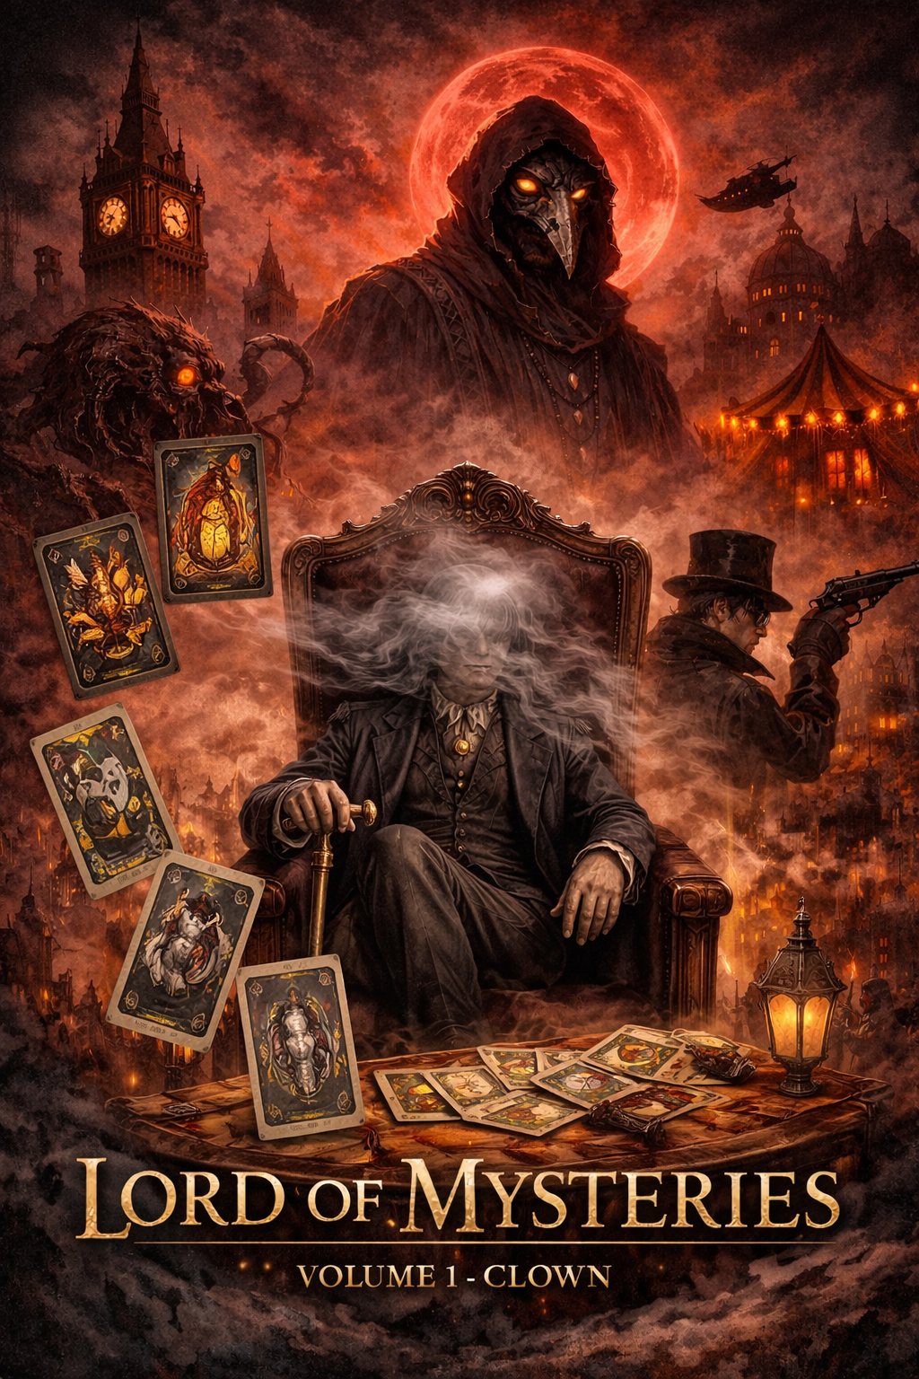

**License & Usage**

This guide is shared under the **Creative Commons Attribution 4.0 International (CC BY 4.0)** license.

You are free to:

* Share this guide
* Adapt or update it
* Create your own versions or extensions

**As long as you credit the original work**:

*“Based on the Lord of Mysteries Episode Guide by [blacksensei01].”*

This guide is **non-commercial** and made purely to help anime viewers understand the story and encourage reading the original web novel by the author.